**05/10/2021 CD SPOT 5 2019103573**

**SPOT – EXERCISE**

**1. Append the next matched string to the current value of the yytext rather than replacing the contents of the yytext. Handle it for Uppercase and Lowercase**

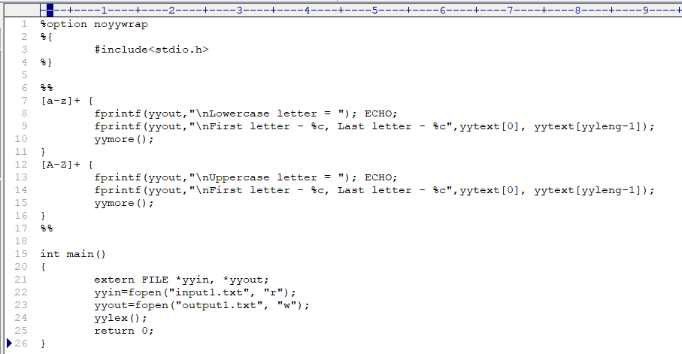**CODE :-**

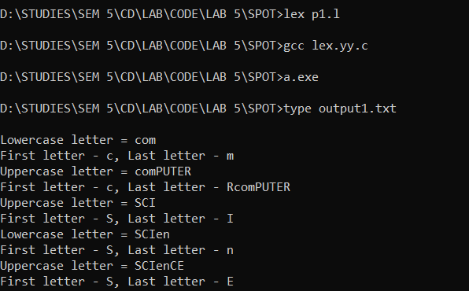**OUTPUT :-**

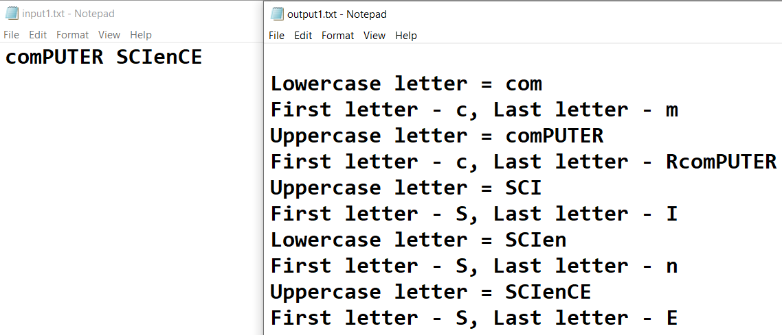

**2.Match any string of one or more character that do not include lower case a-z.**

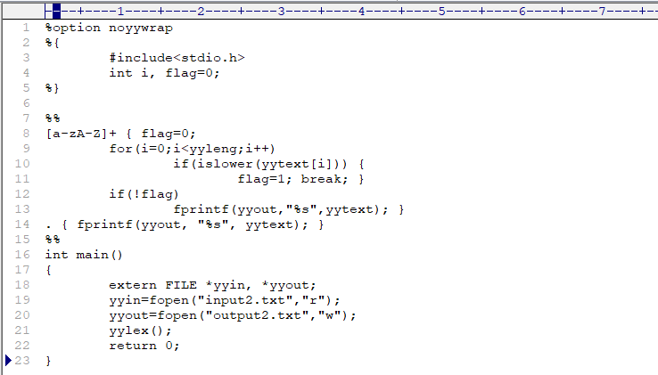**CODE :-**

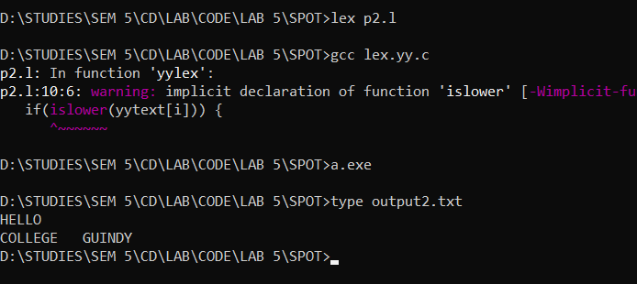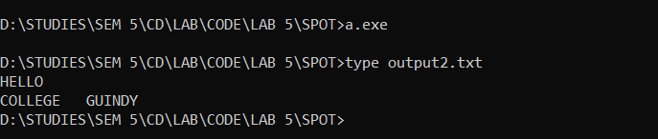**OUTPUT :-**

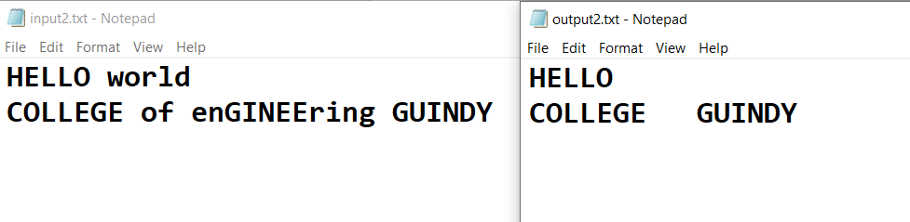

**3.Comments consisting of string surrounded by /* and */ without intervening */, unless it is inside double-quotes(“)**

Input:

{

while ( (c = input()) == '*' )

;

if ( c == '/' )

break; /* found the end */

}

while (c ! = eof)

{if (c = =1 )

return “YES”; /* Returns YES */

else

return “NO”; /* Returns NO */

}

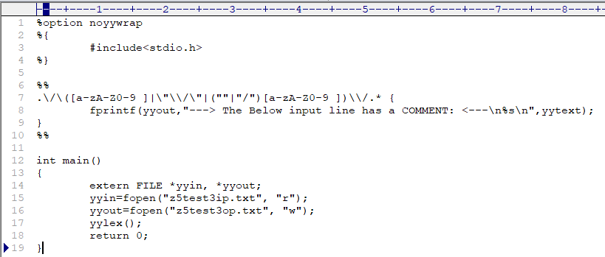**CODE :-**

**OUTPUT :-**

